**Medical Distributed Ledger Technology**

Programming with Advanced Computer Languages - Python

**Team Snakes**: Johanna Husson, Christopher Newson, Dominik Eitljörg, Dean van der Merwe …(please add your full names)

**Description**

This project creates a distributed ledger technology (DLT) to store patient data. The intended users are physicians who need to access and modify patients’ files during or after a medical consultation, to register diagnoses and prescribed medications. Pharmacists are also potential users, to register medications bought by a given patient. The blockchain architecture ensures traceability of all actions undertaken on a patient file by alerting the user when a file has been tampered with.

A patient file is stored as a dictionary. A hashing algorithm, which assigns a cryptographic key to its input (here, input is a dictionary), ensures the integrity of patient data because: 1- It is impossible to have the same hash for two different inputs; 2- The exact same patient dictionary produces the same hash; 3- Conversely, any change to the dictionary modifies the hash.

A blockchain (BC) is automatically created when the program is started. The blockchain is only stored as long as the program is running. Every block includes an index number, the previous block’s hash and the hash of the patient data. Whenever the user changes his data, a new block is created with a new hash. Hashes of every action are saved in a list which can be visualized by the user. When starting the program, the user is prompted to either add a new patient file or load an existing file. In the latter case, the code checks the hashes from the previous blocks and uses this to verify whether the data was once created within the program or if it was created / altered by some third party.

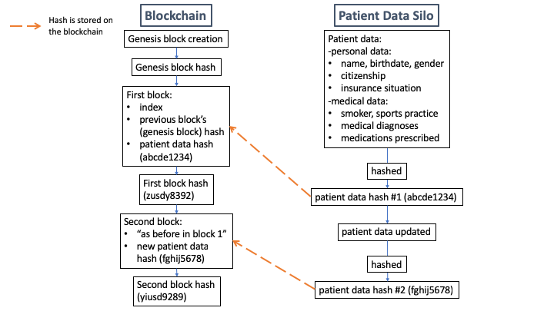

*Figure 1: Visualisation of our blockchain technology for patient data.*

*The patient data itself is not stored on the blockchain, only the hash identifying it is stored. Therefore a user cannot see the content of a patient file, but can only see the resulting hash to verify data has not been tampered with.*

**Instructions**

1. Run the program to create a blockchain:

You are asked to enter the first patient’s information. A new block is created.

You can later add new patients files (Option 1).

Alternatively, you can load an existing patient file to modify it (Option 2). In case of modification, a new hash is created and a new block is added to the blockchain.

Finally, you can visualize the list of hashes stored on the blockchain (Option 3).

1. Test the ability of the program to identify a corrupted file:

Try loading a test file: xxxxx

Receive a message “*Patient data is corrupted*”: the new hash does not correspond to the hash loaded.

Run program a first time ⇒ filed stored locally. Close program.

Run program a 2d time ⇒ try to load file. Corrupted.

1. Terminate the program (Option 4)

The blockchain is lost when the program is terminated.

**Requirements**

None, all libraries come installed with Python.